|  |
| --- |
|  |
| Capstone Project Document |

**First Aid**

Report #6 – User Guide

|  |  |  |
| --- | --- | --- |
| **First Aid** | | |
| **Group Members** | Đàm Huy Hùng | SE03431 |
| Nguyễn Duy Anh | 01525 |
| Mai Trung Kiên | SE02994 |
| Nguyễn Tiến Dũng | SE03272 |
| Nguyễn Phúc An | SE03118 |
| **Supervisor** | Mr. Nguyễn Văn Sang | |
| **Project code** | FAVN | |

**- Hanoi, 12/2015 -**

# SIGNATURE PAGE

AUTHOR: Nguyễn Phúc An **25/11/2016**

Team member

REVIEWERS: Đàm Huy Hùng **26/11/2016**

Project manager

APPROVAL: Nguyễn Văn Sang **26/11/2016**

Supervisor

Record of change

*A - Added M - Modified D – Deleted

|  |  |  |  |  |  |
| --- | --- | --- | --- | --- | --- |
| Effective Date | Changed Item | A,M,D | Change Description | Reason for Change | Rev. Number |
| 25/11/2016 | User installation | A | Add new |  | 1.0 |
| 29/11/2016 | User guide | A | Add new |  | 1.0 |
|  |  |  |  |  |  |
|  |  |  |  |  |  |
|  |  |  |  |  |  |
|  |  |  |  |  |  |
|  |  |  |  |  |  |
|  |  |  |  |  |  |
|  |  |  |  |  |  |
|  |  |  |  |  |  |
|  |  |  |  |  |  |
|  |  |  |  |  |  |
|  |  |  |  |  |  |
|  |  |  |  |  |  |
|  |  |  |  |  |  |
|  |  |  |  |  |  |
|  |  |  |  |  |  |

Table of Contents

SIGNATURE PAGE 1

1 INTRODUCTION 3

2 USER GUIDELINES 3

2.1 First Aid 3

2.2 Ambulance 18

2.3 Admin 25

2.4 Dispatcher 31

# INTRODUCTION

This user's manual has been created to help users better understand the features of each application of First Aid Viet Nam system. Morever, help users understand how to use the features correctly by providing them simple step by step tutorials.

# USER GUIDELINES

## First Aid

This is the first screen which user will see. From this screen the user can go to every screen they want to use features.

To use this application, the users do the steps below:

Step 1: Download and install application

Step 2: Launch application

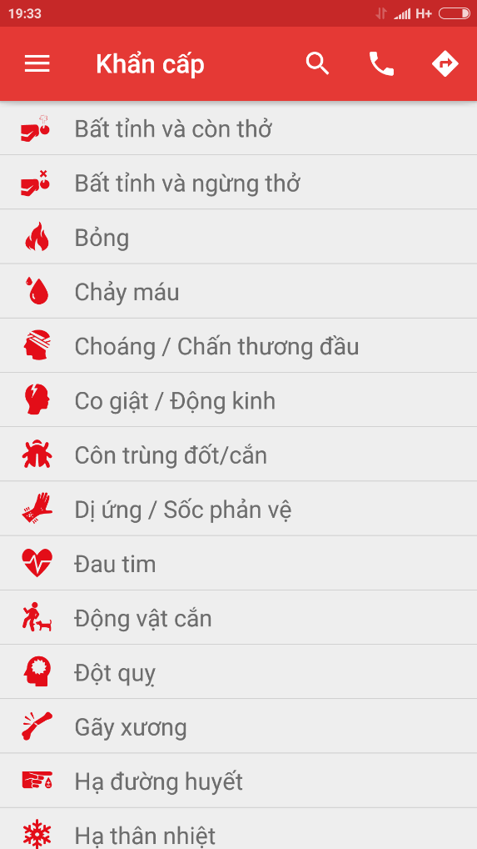

Figure 2‑1 Emergency screen

### Emergency Details

To see the details of emergency, users do the steps below:

Step 1: Launch application

Step 2: Tap on one random emergency case

Step 3: Screen displayed the details of emergency case

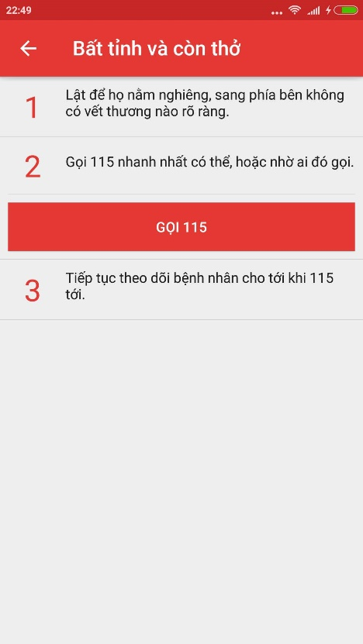

Figure 2‑2 Emergency details screen

### Search emergency case

To search emergency case, the users do the steps below:

Step 1: Launch application

Step 2: Click on button search of “Hướng dẫn sơ cứu” screen

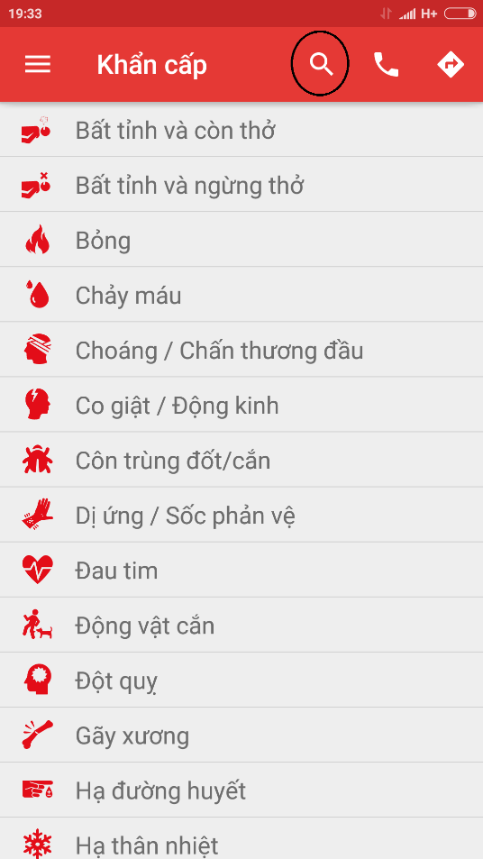

Figure 2‑3: Search icon

Step 3: Input the characters you want to search in textfield

Step 4: Screen display the result

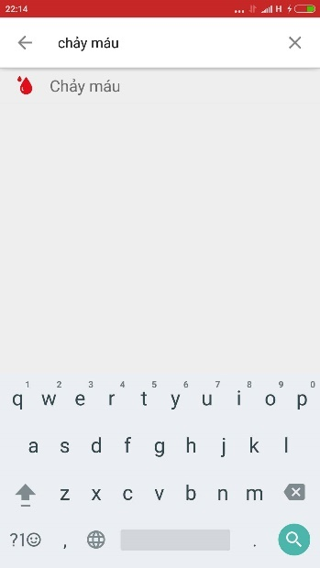

Figure 2‑4: Search result screen

### Call 115

To use Call 115 function on this application, the users do the steps below:

Step 1: In “Khẩn Cấp” screen, tap on icon “Call”

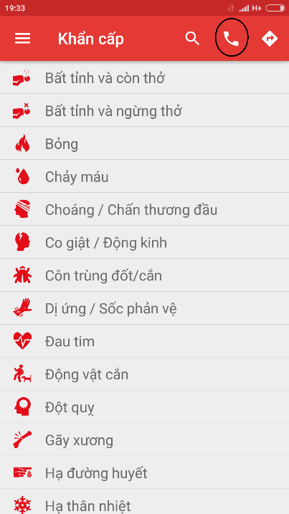

Figure 2‑5 Icon Call

Step 2: Call 115 screen is displayed

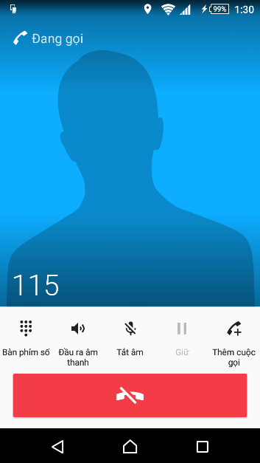

Figure 2‑6: Call 115 screen

### Direct

In this function, user can know about current position, 20 nearest health facilities, direct from current position to selected health facility.

Step 1: Launch Application

Step 2: Click on icon direct

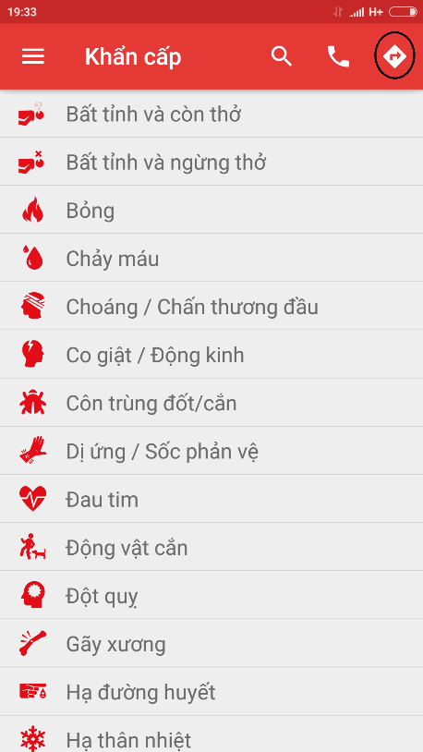

Figure 2‑7 Icon Direct

Step 3: Screen displayed map and current position, tap on button “Cơ sở y tế gần đây” to see the list of nearest health facilities

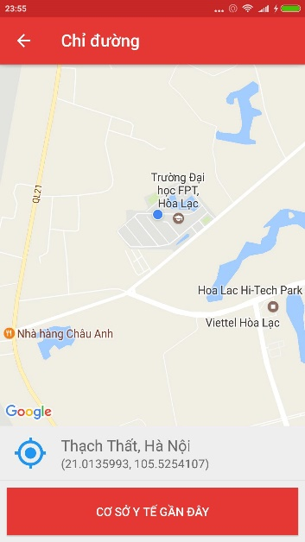

Figure 2‑8 Direct screen

Step 4: Select one of health facilities list (figure 2-9) , then tap on button direct ( figure 2-10 )

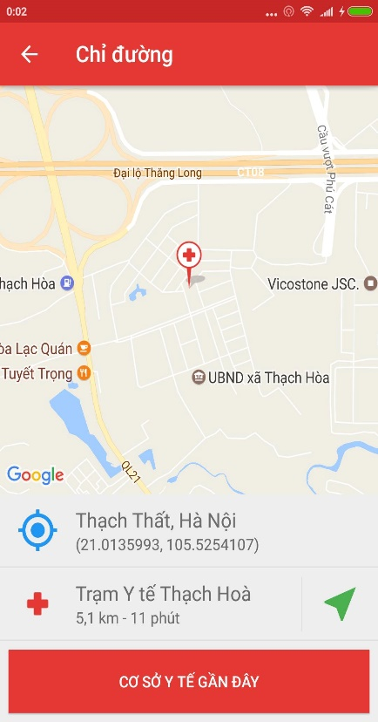

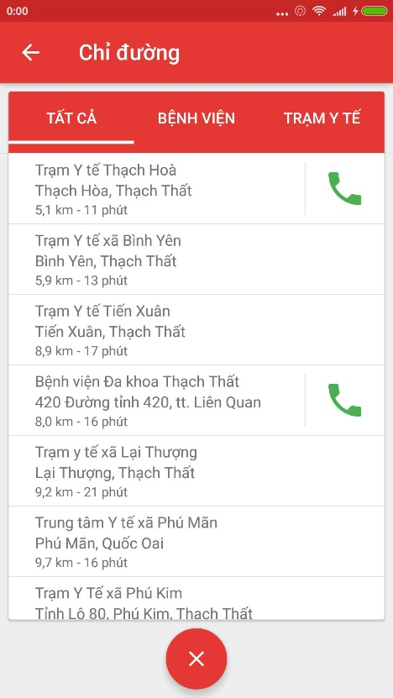

**Figure 2-9: List of health facilities Figure 2-10 Button Direct**

Step 5: Tap on button direct, screen show the direct from current postion to the selected health facility

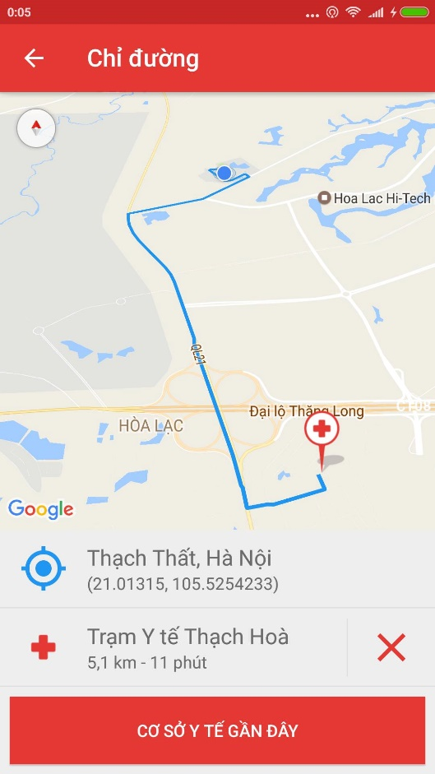

**Figure 2-11: Direct from current position to the emegency case**

### Learning

In this screen, users can view the detail of learning topic, view the list of câu hỏi thường gặp, can send the question to the system. To use those feature, user do as step belows:

Step 1: Launch application

Step 2: Tap on icon Menu

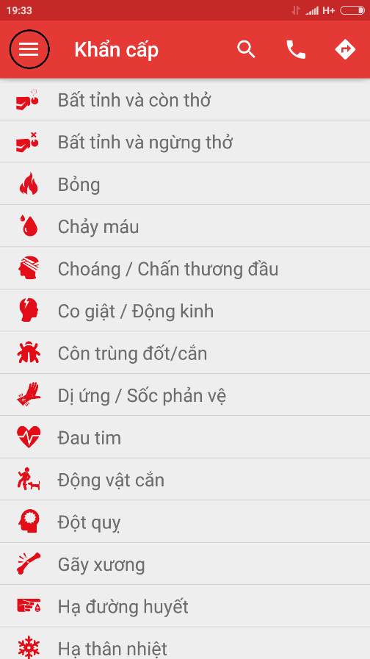

**Figure 2-12: Icon menu**

Step 3: Tap on icon Tìm Hiểu

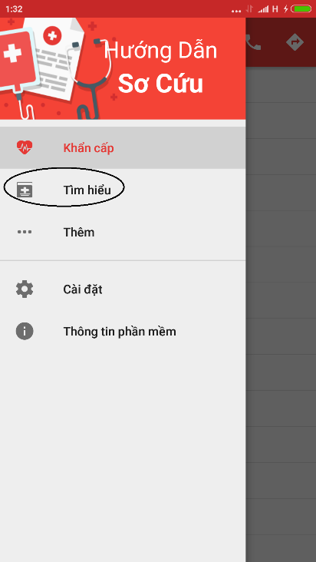

**Figure 2-13: Learning Icon**

Step 4: Screen displayed list of learning topic

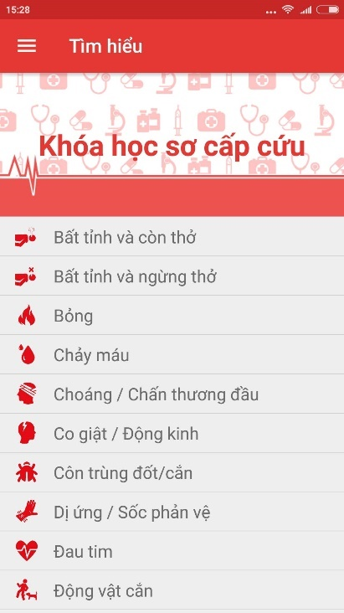

**Figure 2-14: Learning screen**

Step 5: Tap on random topic

Step 6: Screen displayed details of selected topic

Step 7 : Tap on button “ Câu hỏi thường gặp” to view the list of FAQ

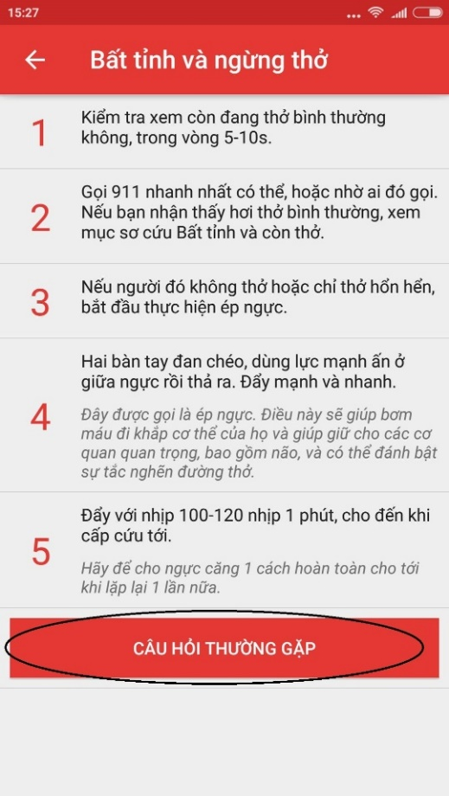

**Figure 2-15: FAQ button**

Step 8: Screen displayed list of FAQ

Step 9: Tap on button “ Đặt câu hỏi cho chúng tôi” to send question to system

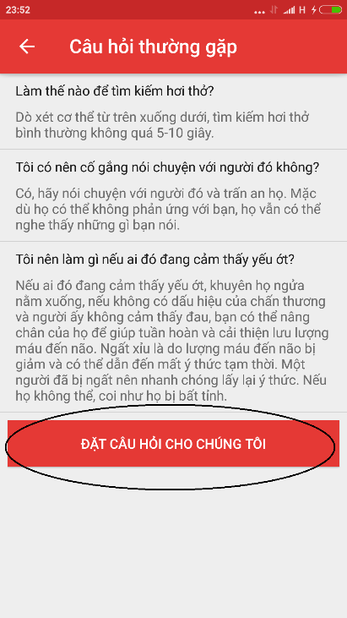

**Figure 2-16: Send question button**

Step 10: Fill all field and tap on button “ Gửi”

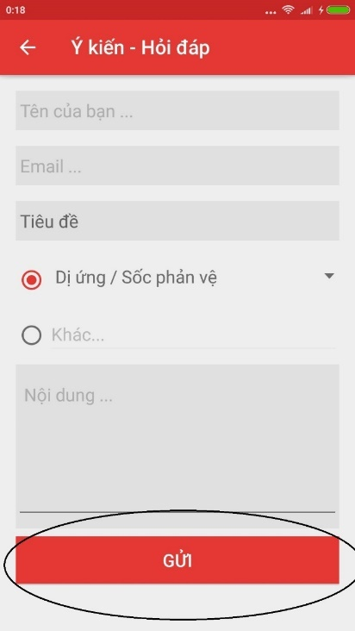

**Figure 2-17: Send button**

### Setting

In this screen, you can setting to send or not send your location and phone number. To use features in this function, users do the steps below:

Step 1: Launch app

Step 2: Tap on icon Menu and select Setting

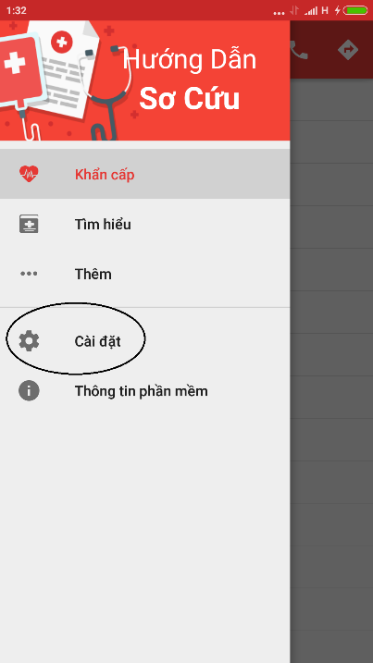

**Figure 2-18 : Setting icon**

Step 3: If you want to send information, tap on button “Đồng Ý Gửi” (ảnh)

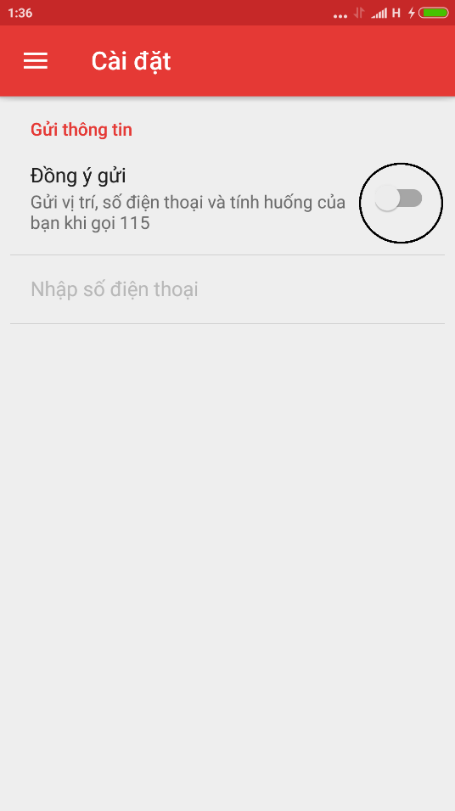

**Figure 2-19: Allow to send information switch**

Step 4: Tap on “Nhập số điện thoại” to input your phone number

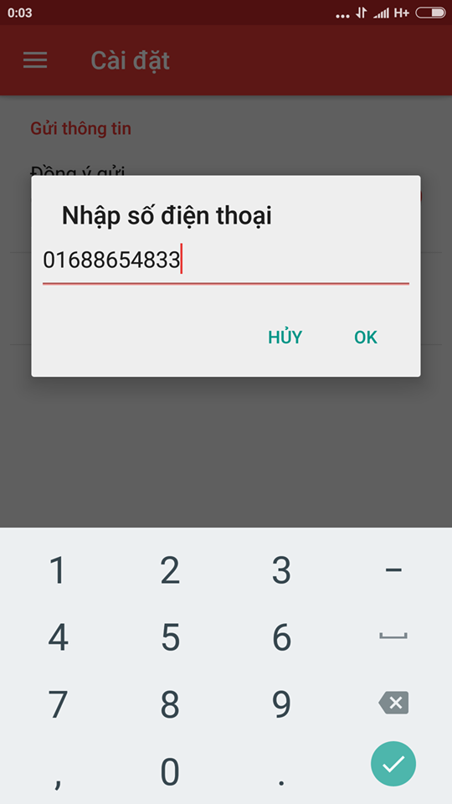

**Figure 2-20 : Fill phone number dialog**

Step 5: Tap on button OK, your phone number displayed on the screen

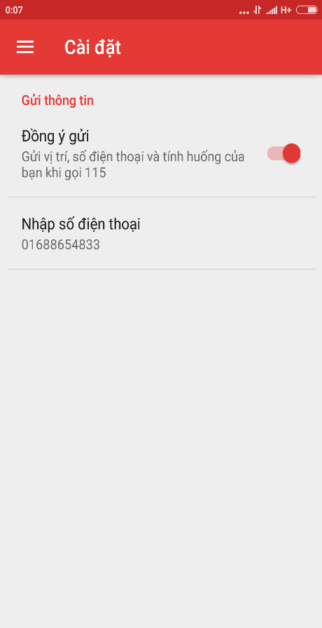

**Figure 2-21: Phone number display on screen**

### Software information

In this screen, you can view the information of software like version, term of use, information of developers.

Step 1: Launch application.

Step 2: Tap on icon Menu then select “Thông Tin Phần Mềm”.

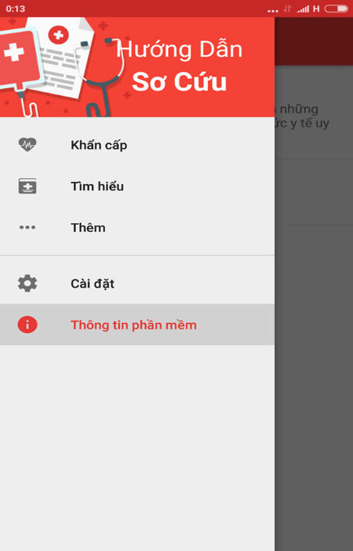

**Figure 2-22: Software information icon**

Step 3: Screen displayed information of software.

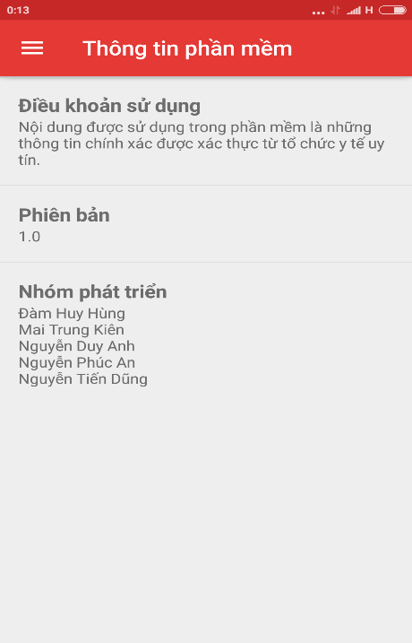

**Figure 2-23: Software information screen**

## Ambulance

This is the first screen which user will see. From this screen the user can go to every screen they want to use features.

Step 1: Download and install application

Step 2: Launch application and login

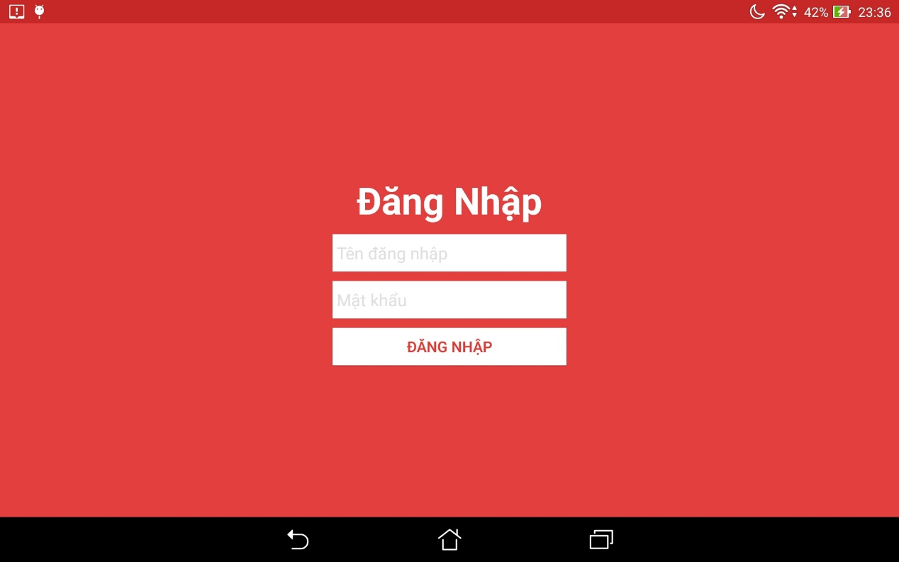

**Figure 2-24: Login screen**

### Logout

To logout application users follow these steps:

Step 1: Tap the icon on the left side of the screen [Menu]

Step 2: Tap on button “ Đăng Xuất”

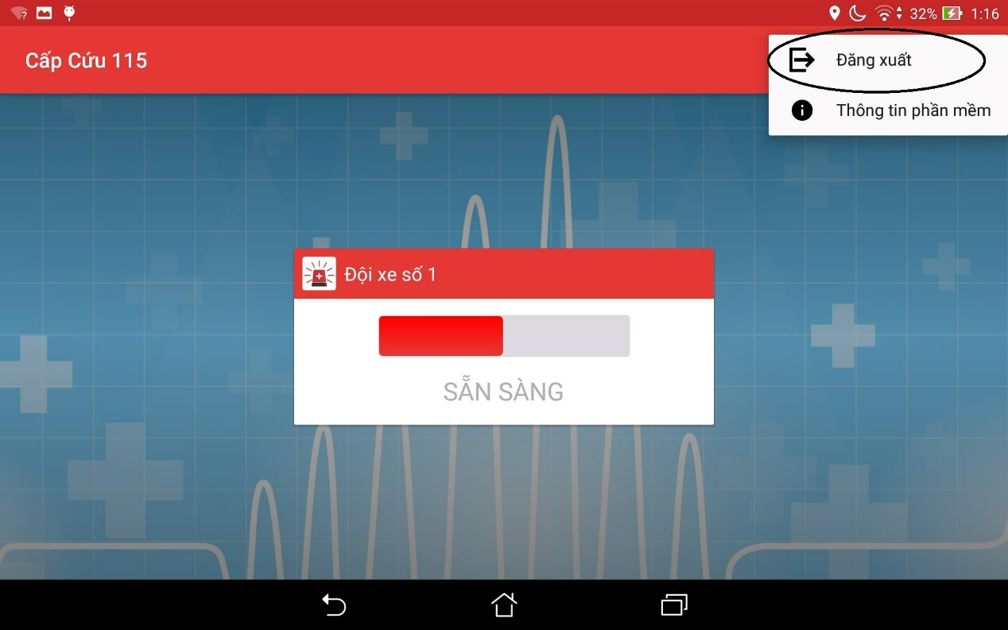 **Figure 2-25: Logout button**

### Ready/Not ready to take the task

Users depending on their current state can decide to take the task or not

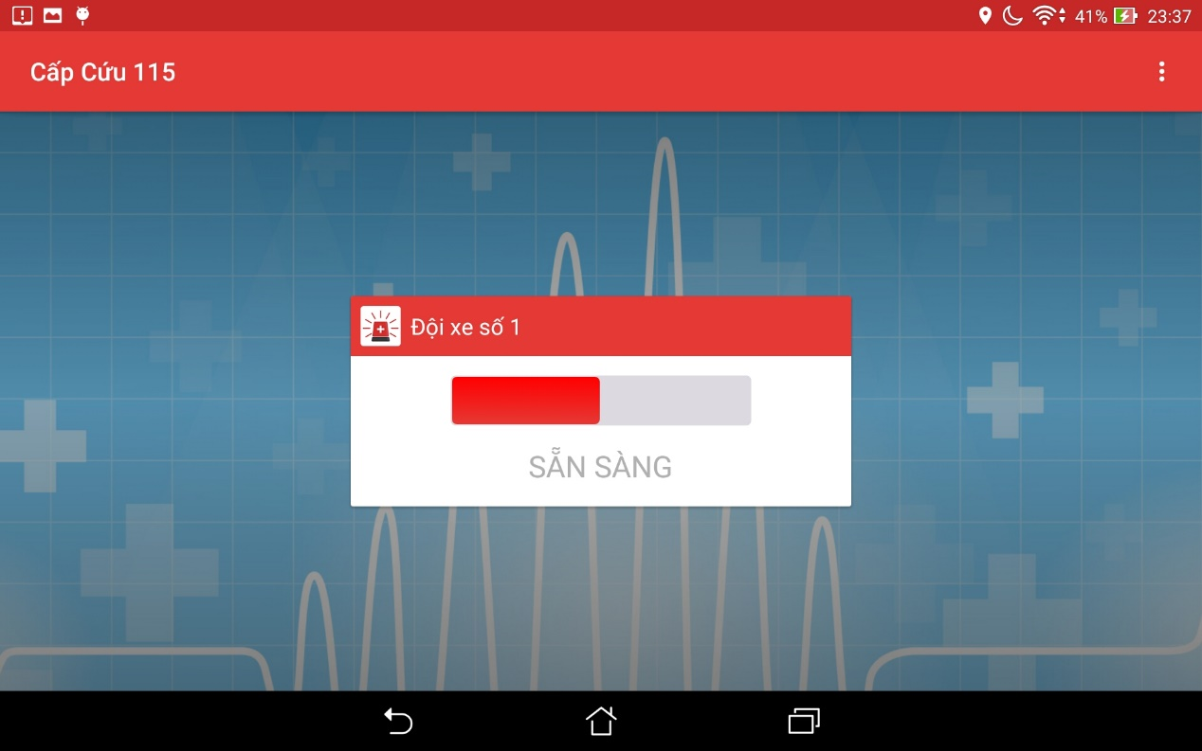 **Figure 2-26: Ambulance status**

### Software information

To see the information about this application, the users do the steps below: ( ảnh)

Step 1: Tap on menu icon at the top right at screen

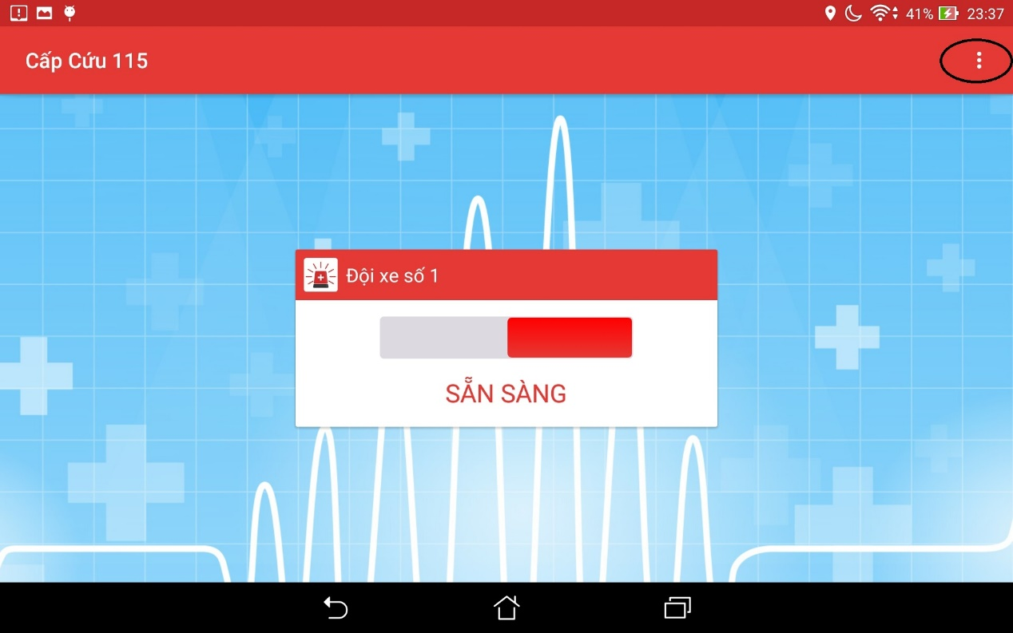

**Figure 2-27: Menu Icon**

Step 2: Tap on button software information

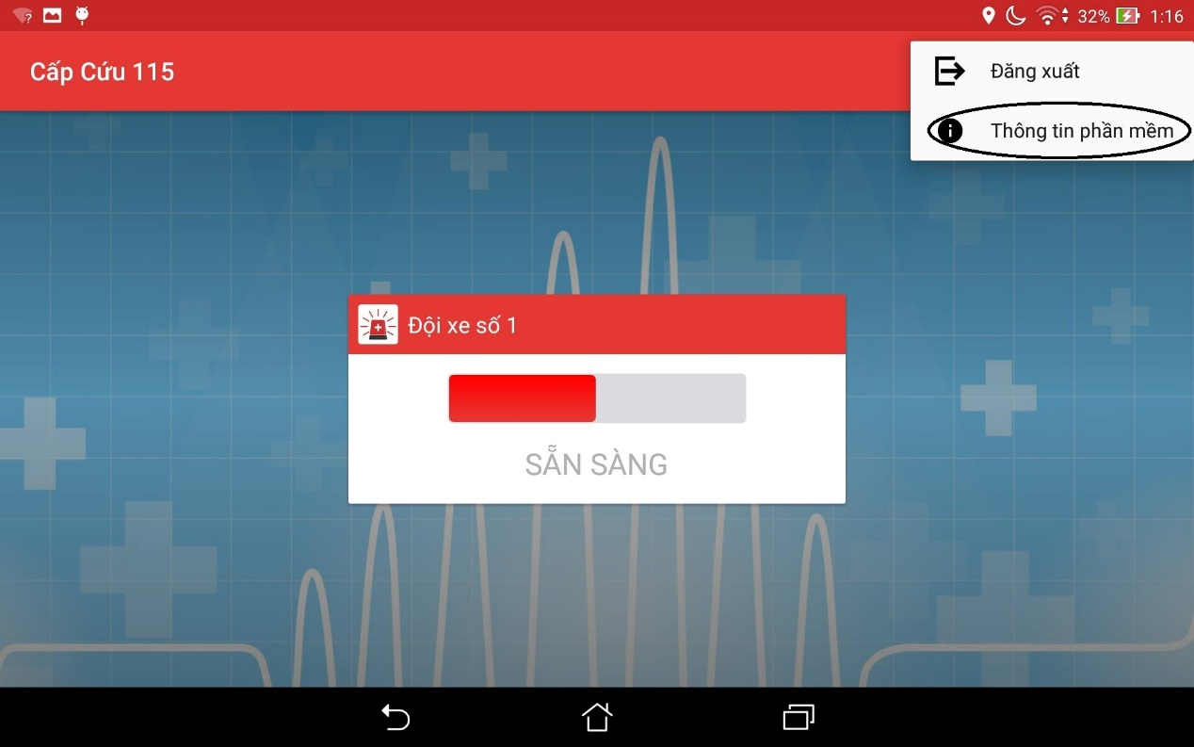

**Figure 2-28: Software information button**

Step 3: Move to software information screen

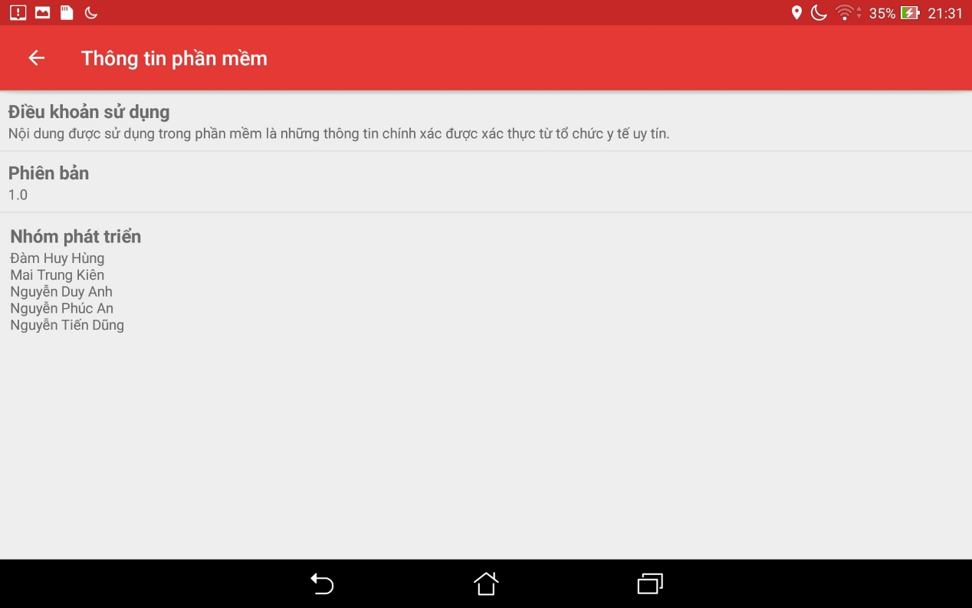

**Figure 2-29: Software information screen**

### Locate

When users want to locate current location, do the steps below:

Step 1: Login the application and take the task

Step 2: Tap on button “Định Vị” 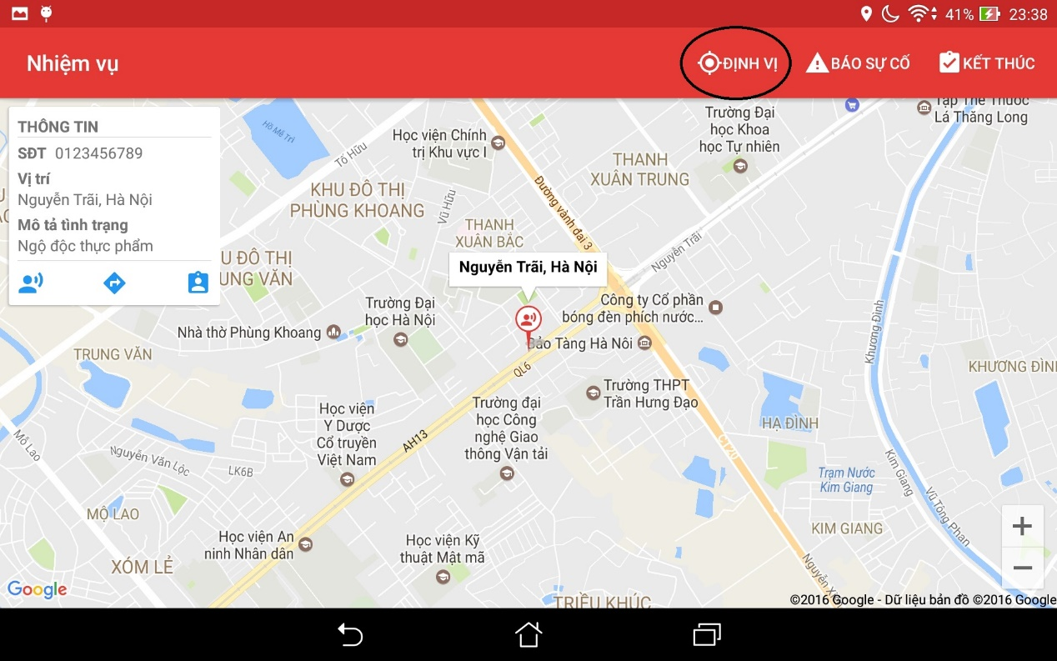

**Figure 2-30: Locate ambulance position’s button**

When users want to locate current location of victims, do the steps below:

Step 1: Login the application and take the task

Step 2: Tap on icon victim

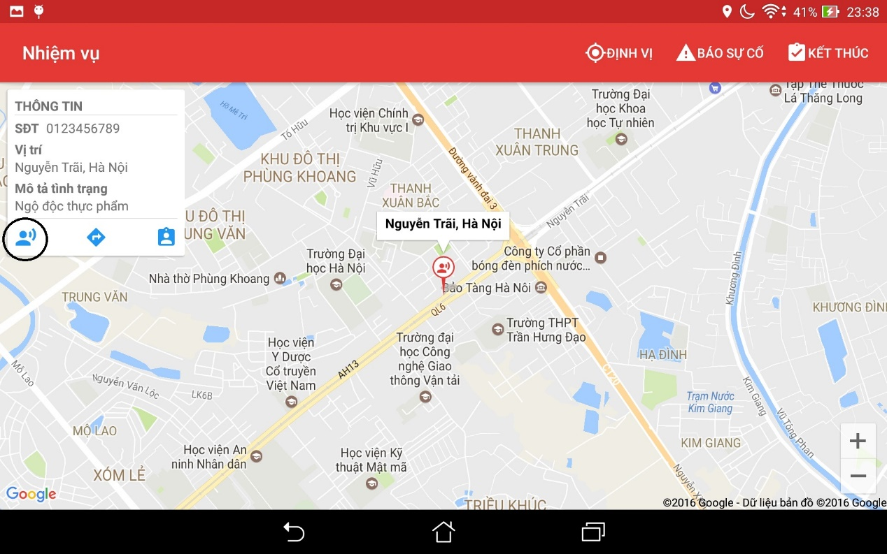

**Figure 2-31: Locate victim’s position button**

### Direct

When users want to view direct from ambulance to the victim position, do the steps below:

Step 1 : Tap on button direct, screen will show the direct

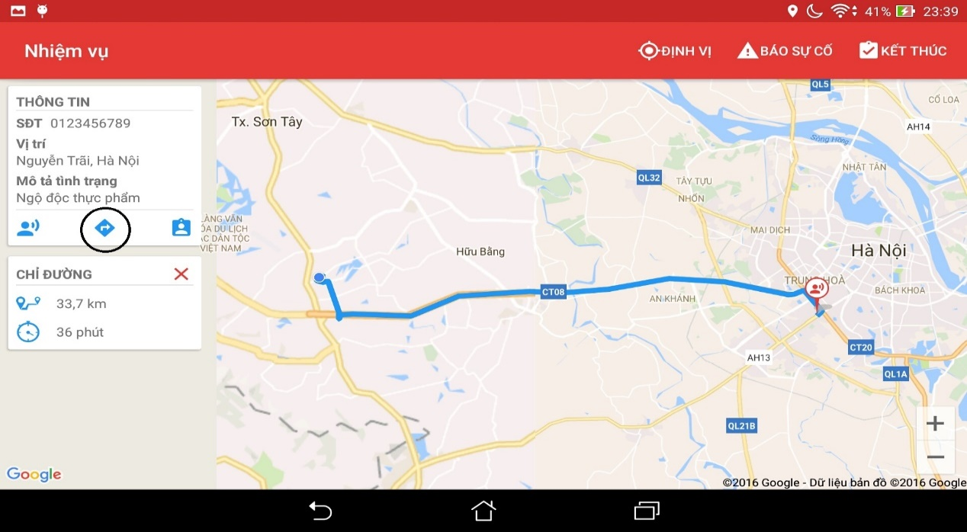

**Figure 2-32: Direct button**

### Picked up victim

When picked up victim, report to the center by the steps below:

Step 1 : Tap on button pick up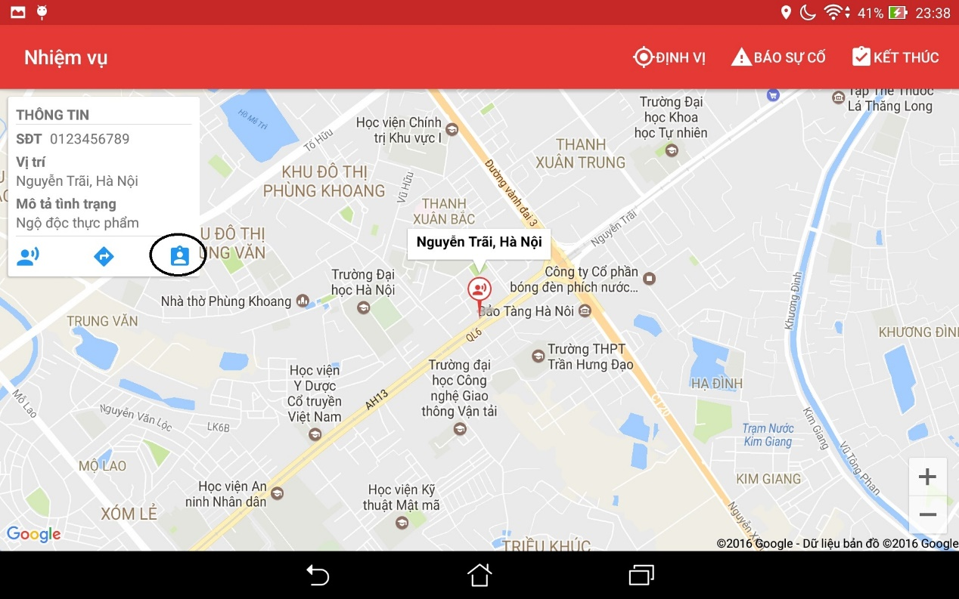

**Figure 2-33: Picked up victim button**

### Report problem

When users have problem, to report to dispatcher, users do the step below :

Step 1: Tap on button “Báo cáo sự cố”

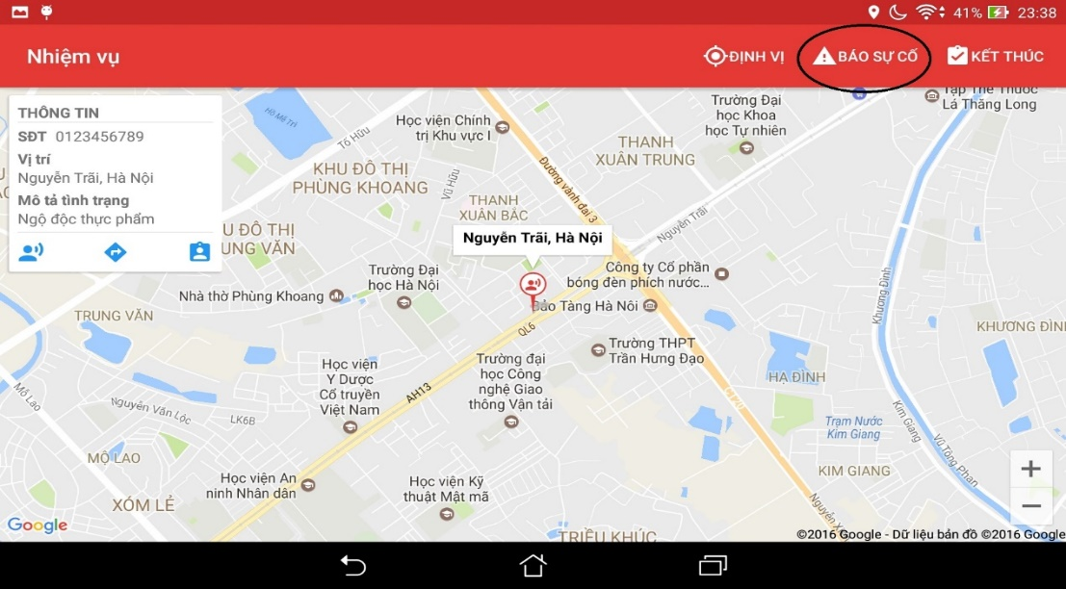

**Figure 2-34: Picked up victim button**

### Finish the mission

When users want to finish their mission, do the step bellows:

Step 1: Tap on the button Finish

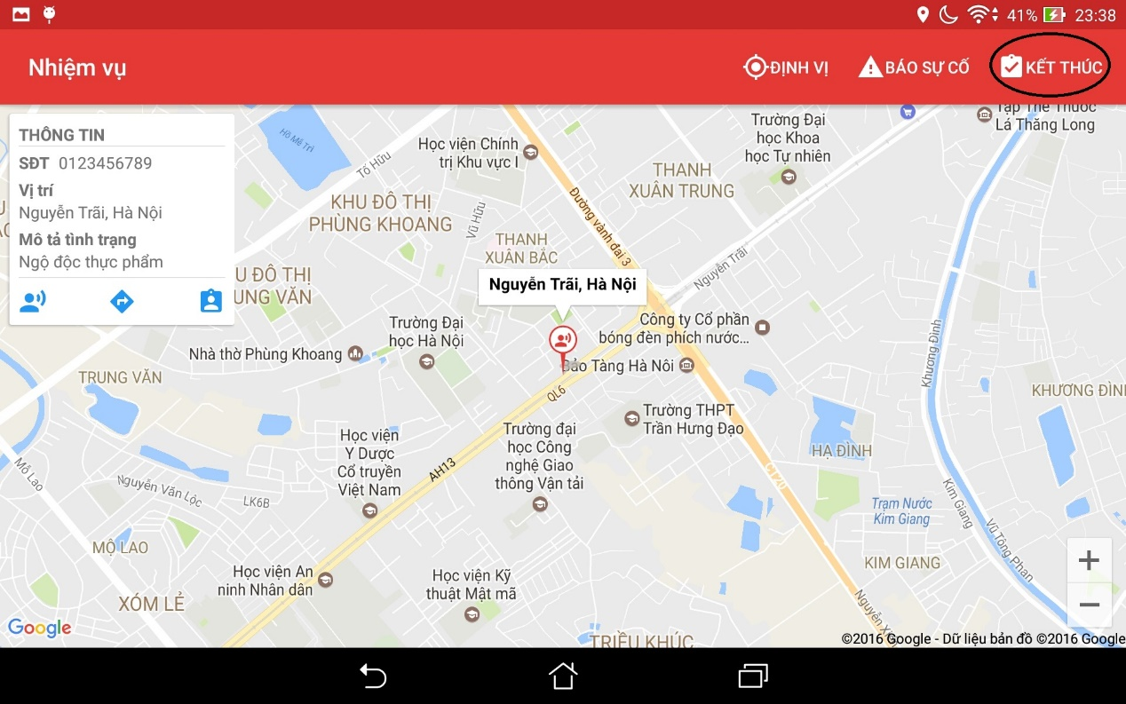

**Figure 2-35: Finish button**

## Admin

In this web application, registered users can add new users with role, edit information of users, delete users, view information of users, classify users by role, search users.

### Login & Logout

#### Login

To use features of this web application, users follow the steps belows :

Step 1: Open browser and enter to the address bar: <http://admin.rtsvietnam.com/>

* Login page is displayed

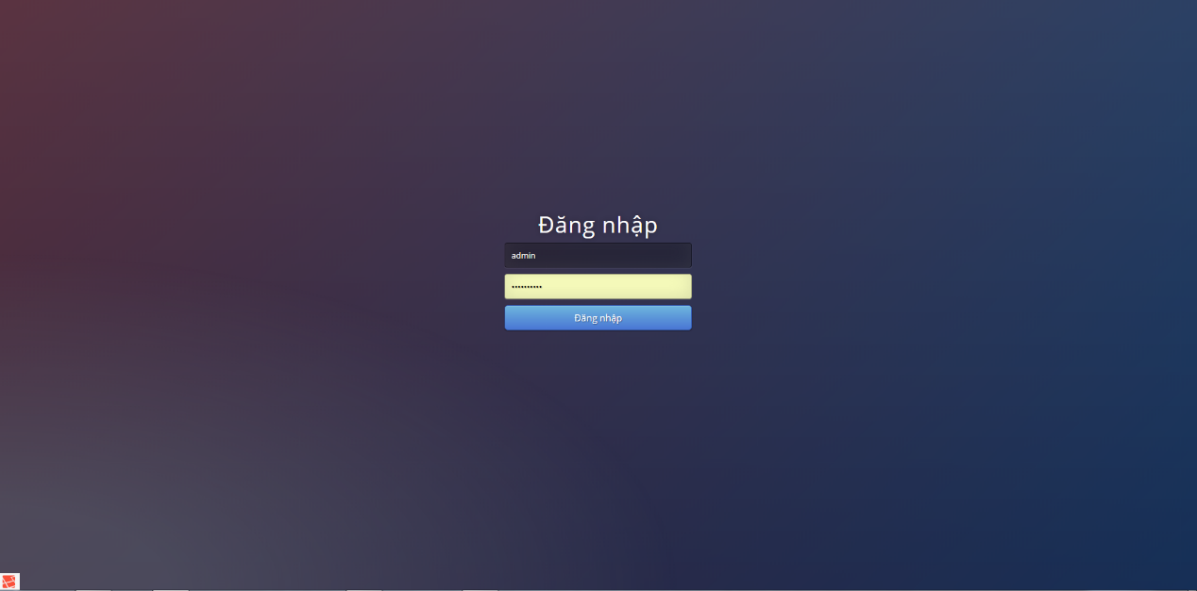

**Figure 2-36: Admin login page**

Step 2: Login with the administration account. Users will go to the Home page. In this page, registered users can go to all of other page.

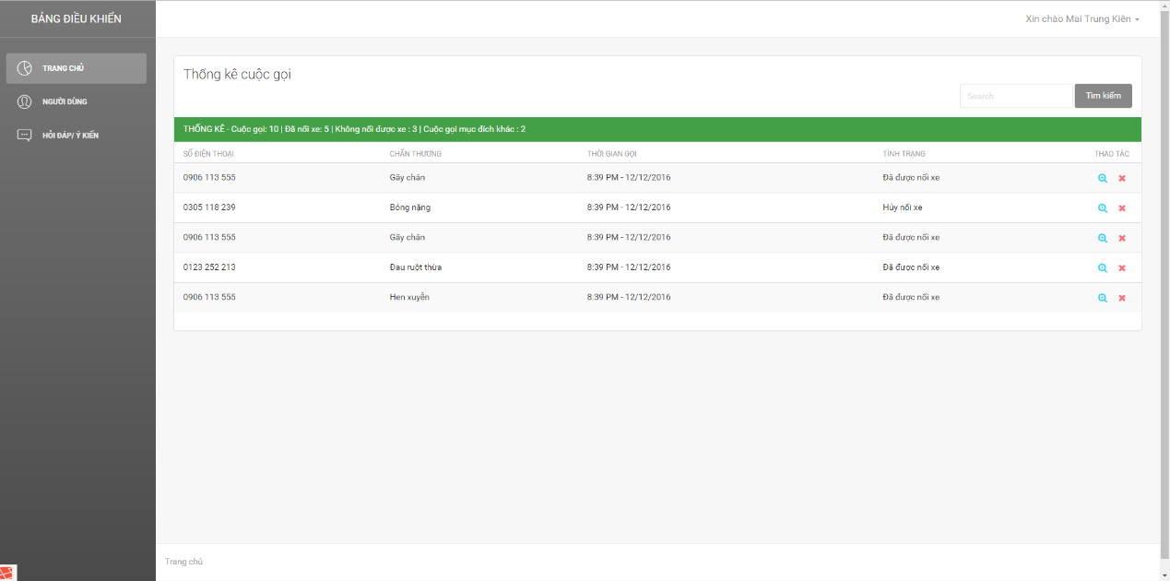

**Figure 2-37: Admin dashboard**

#### Logout

Step 1: On the Home page, click on name of users at the top right of page, then click button “Logout”

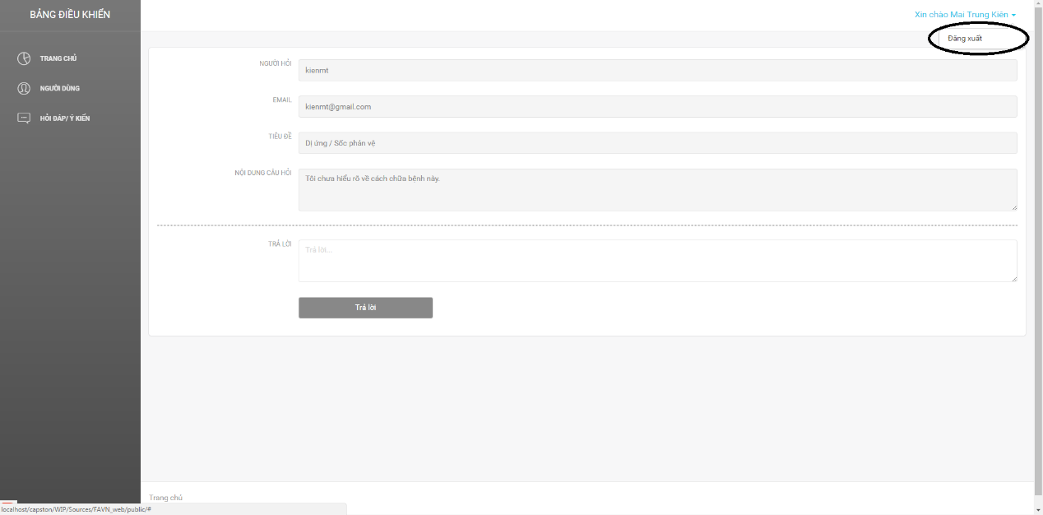

**Figure 2-38: Logout button**

Step 2: Users will go to the login page

### Add new users

To add new users, user do the steps belows:

Step 1: Click on button Users on the menu bar at the left of page

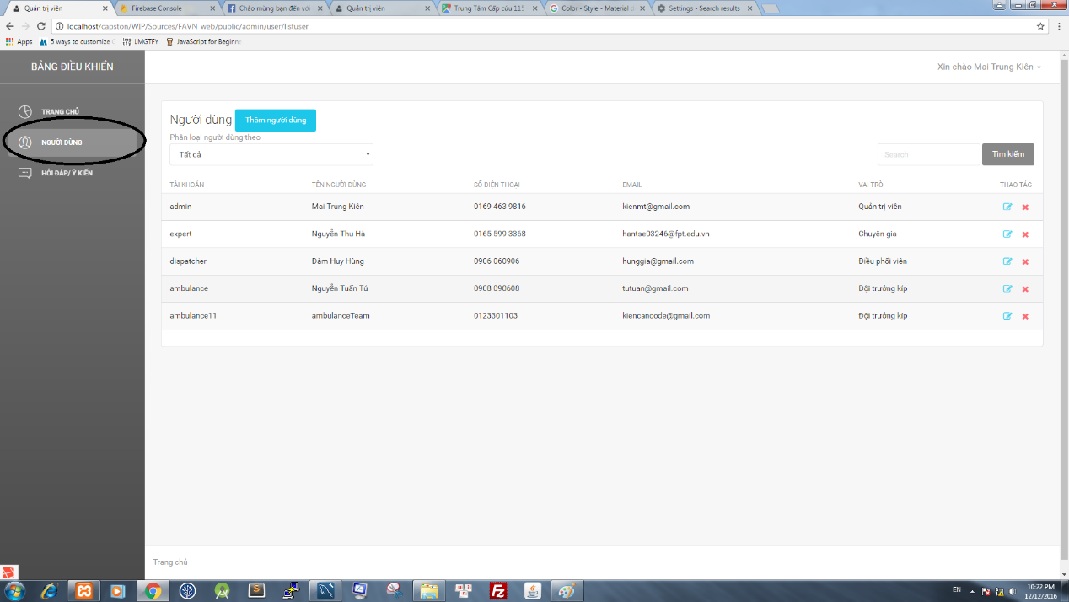

**Figure 2-39: User button**

Step 2: Click on button Add New Users

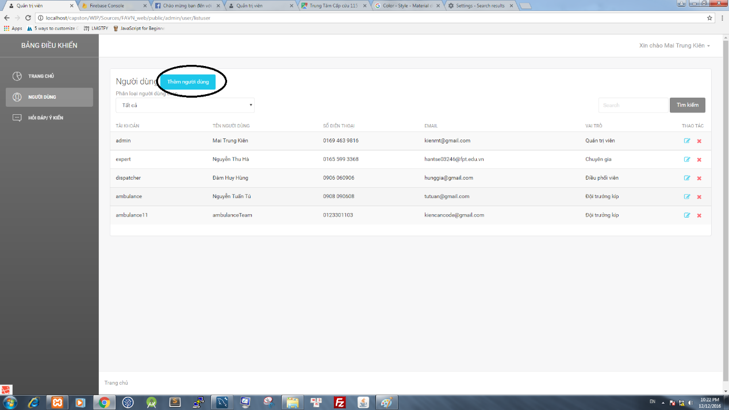

**Figure 2-40: User button**

Step 3: Users wil go to the add new users page

Step 4: Fill validate data on all textfield, then click button Add new user, page will go to the page users, and display messege: “Add new users successfull”

3.1. To reset data all of all field, click on button reset all field will be default

### Classify users by role

To classify users by role, user do the step below:

Step 1: Click on button Users on the menu bar at the left of page

Step 2: Click on the dropdown list belows label “Classify users by” and choose a role

Step 3: Page will display the list of users classify by role

### Search users

To search users, user do the step below:

Step 1: Click on search textbox

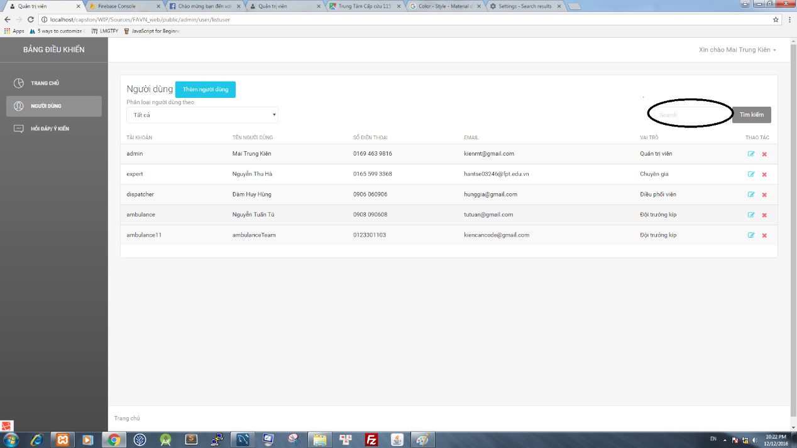

**Figure 2-41: Search Textbox**

Step 2: Input characters then click on button search

Step 3: Page will display the list of result

### Edit users information

To edit users information, users do the step below:

Step 1: Click on icon Edit page will go to the edit users page

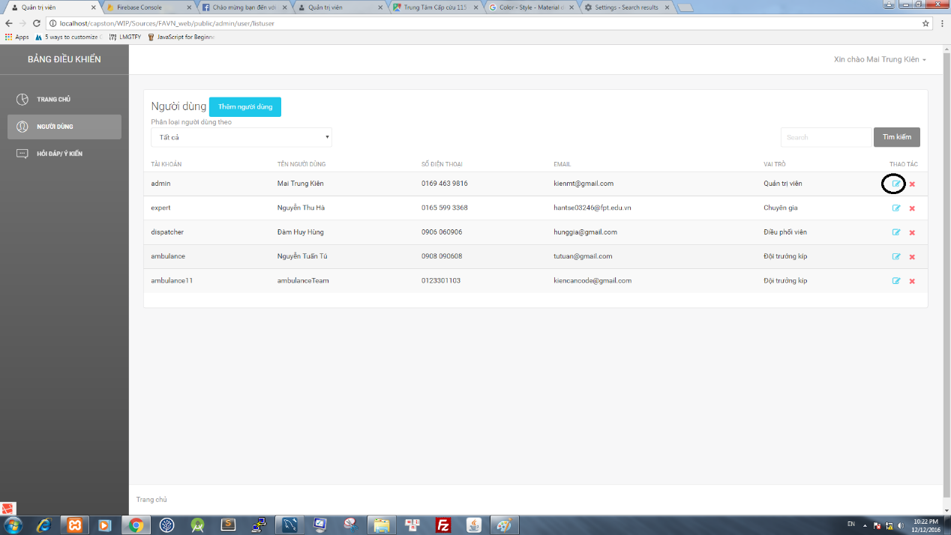

**Figure 2-42: Edit Icon**

Step 2: Edit information of users

Step 3: Click on button Edit, page will display messege : “Chỉnh sửa thông tin thành công”

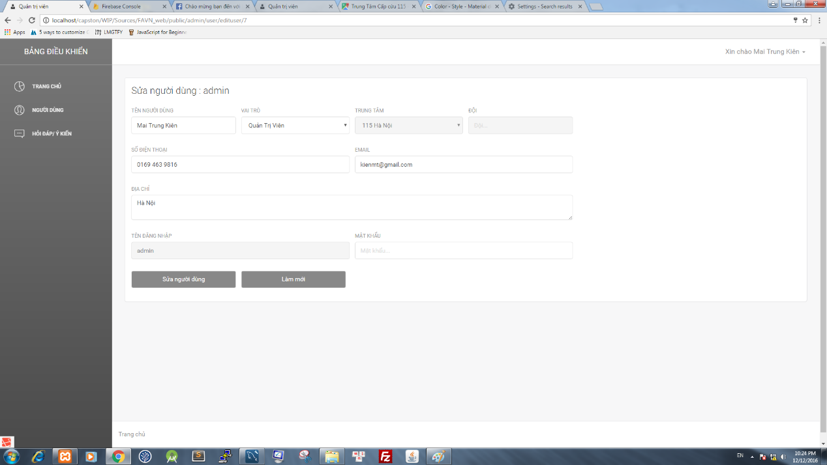

**Figure 2-43: Edit screen**

3.1. To reset data all of all field, click on button reset (ảnh), all field will be default

### Delete users

To delete users, user do the step belows:

Step 1: Click on icon delete users, a confirm dialog will display

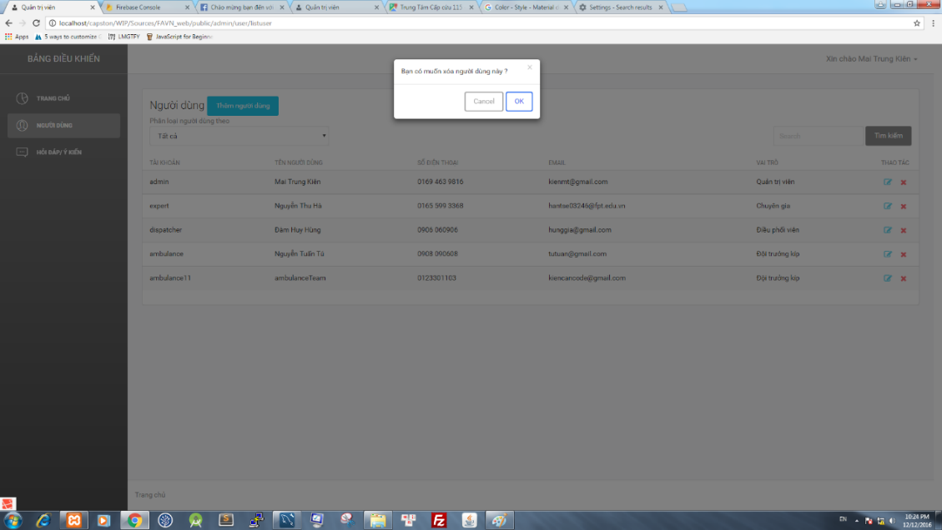

**Figure 2-44: Confirm delete user dialog**

Step 2: Click on button OK, users will be deleted

### Question – Answers.

To use this feature, user do the step belows:

#### **Answer the question**

Step 1: Click on button “Question- Answers “ on the menu bar at the left of screen

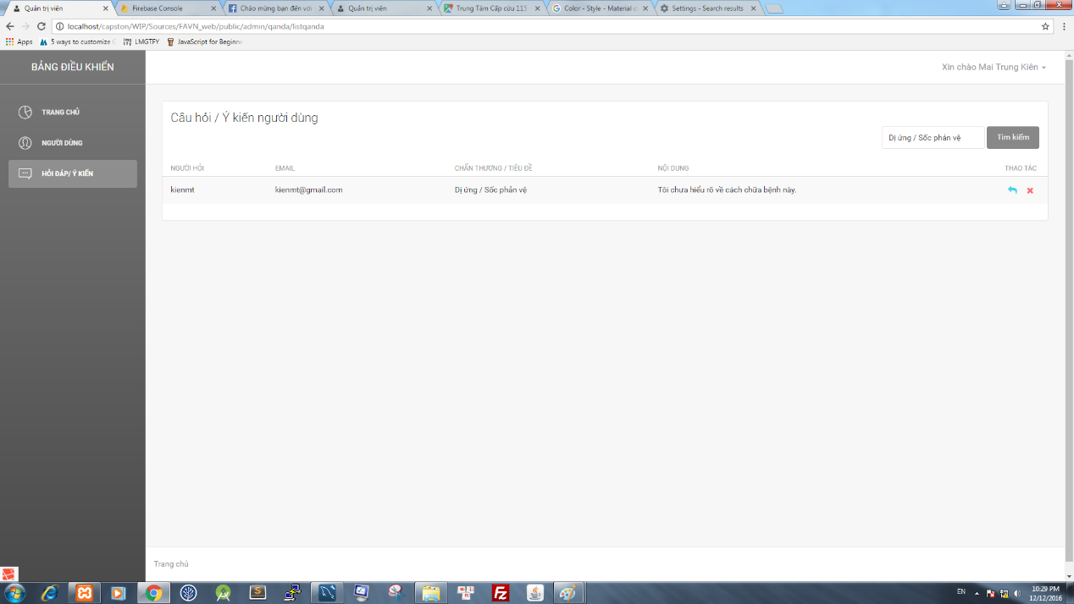

**Figure 2-45: Question-Answer screen**

Step 2: Page will go to the page “Question-Answers”, show the list of question

Step 3: Click on icon answers to answers the question, page will be move to answer question

Step 4: After fill all field, click on button send

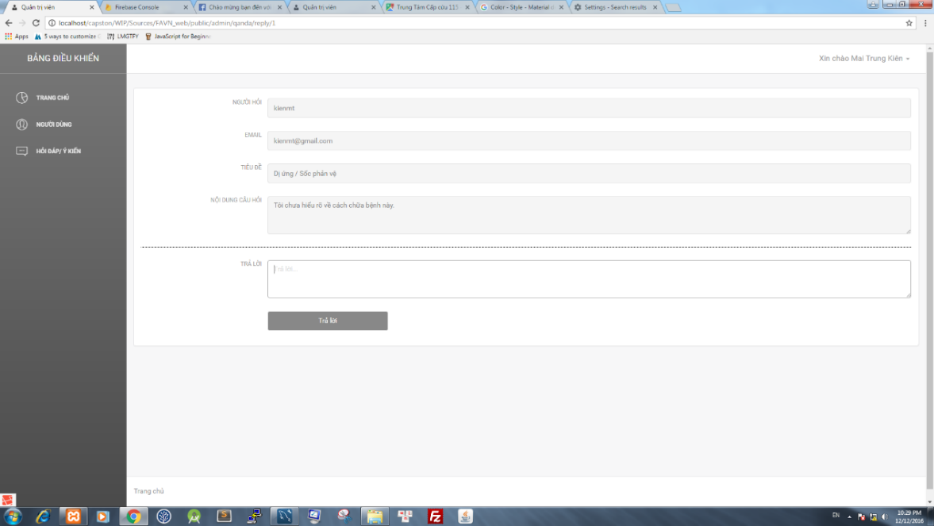

**Figure 2-46: Answer screen**

#### Delete the question

Step 1: Click on button “Question- Answers “ on the menu bar at the left of screen

Step 2: Page will go to the page “Question-Answers”, show the list of question

Step 3: Click on icon delete, a confirm dialog will be display

Step 4: Click on button OK, Question will be deleted

## Dispatcher

In this web application, registered users can receive emergency cases, view the list of ambulance with their information like status, position. Morever, registered users can dispatch ambulance to the emergency case, manage ambulance team.

To use features of this web application, users follow the steps belows :

Step 1: Open browser and enter to the address bar: <http://dispatcher.rtsvietnam.com/>. Login page is displayed

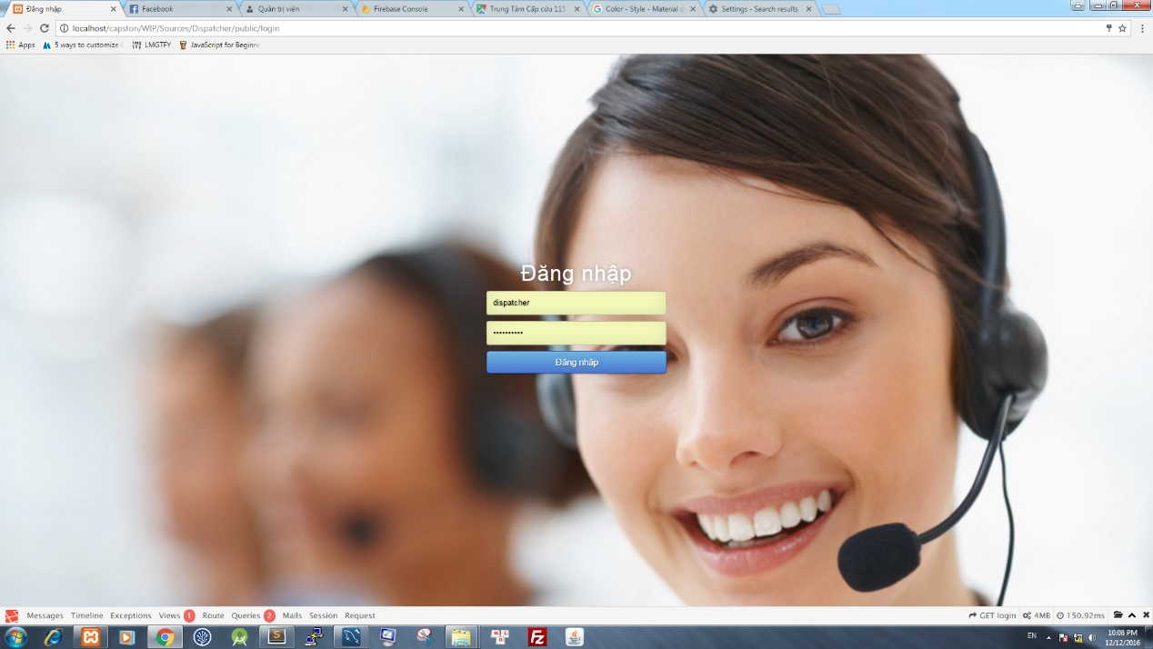

**Figure 2-47: Answer screen**

Step 2: Login with the dispatcher account. Users will go to the Home page. In this page, registered users can go to all of other page.

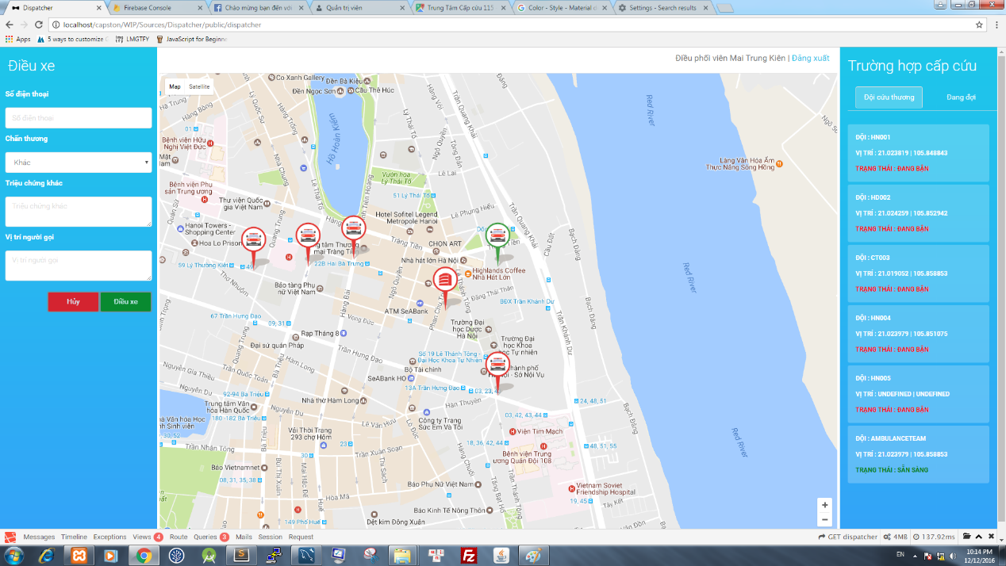

**Figure 2-48: Dispatcher screen**

### Log out

To use this features, user do the steps below:

Step 1: Click on button “ Đăng Xuất”

Step 2: Click on button “OK”

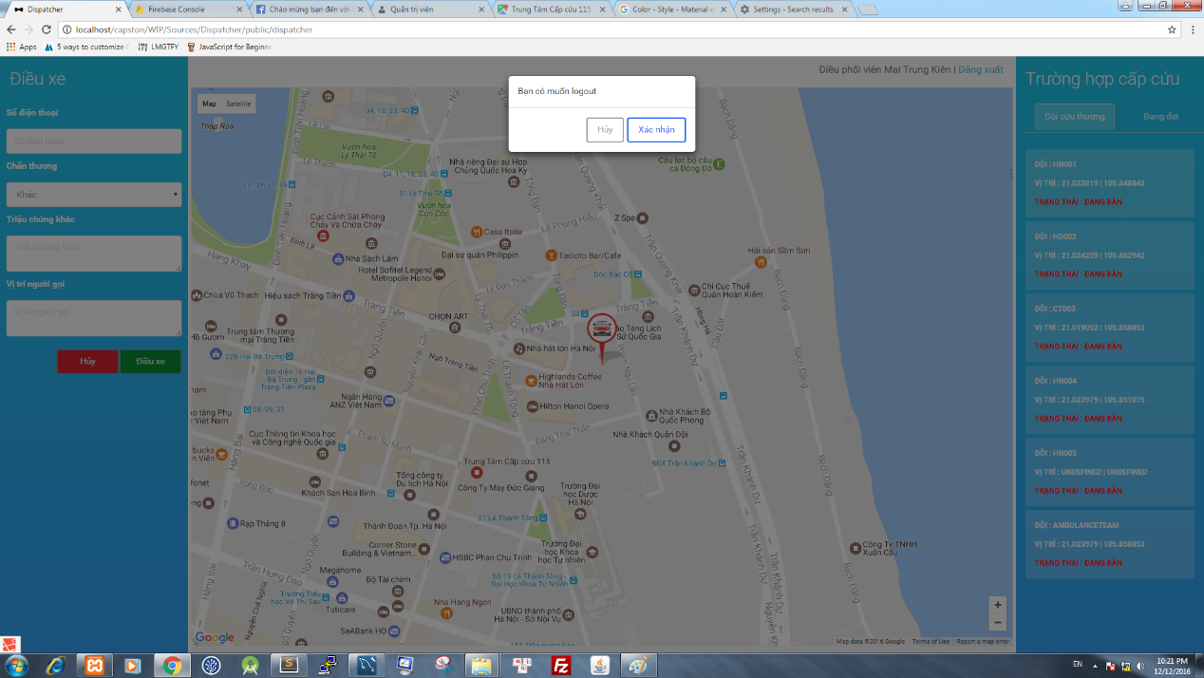

**Figure 2-49: Confirm Logout Dialog**

### Receive emergency case

To use this features, user do the steps below:

Step 1: Login with the dispatcher account.

Step 2 : When dispatcher receive an emegency case, fill all information in the corresponding fields

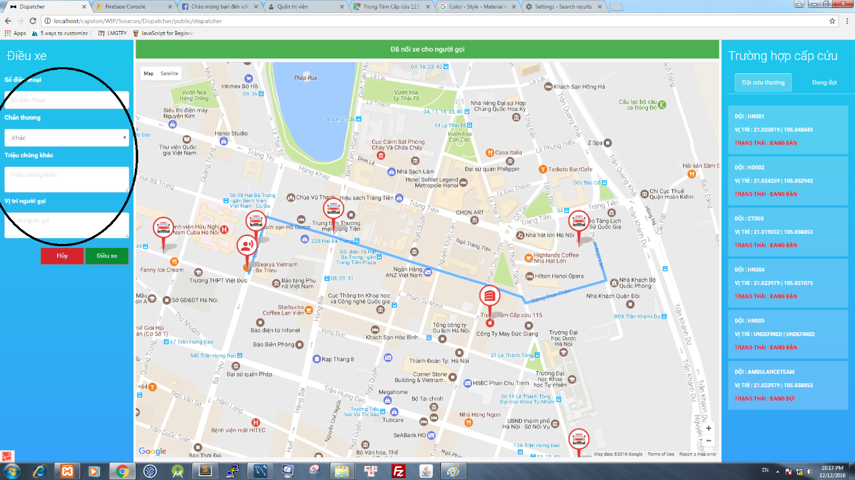

**Figure 2-50: Caller form**

Step 3: Click button “ Điều phối”, ambulance will be dispatched, in the case of unavaible ambulance the notification " Đã hết xe " will be shown on the screen

### Because of the problem, have cancel ambulance

If the dispatcher setups an ambulance, but on the way to perform the tasks, the ambulance gets problem and can not do continuously the tasks, the dispatcher use this function

Step 1: Click on the ambulance having trouble

Step 2: Information of emergency cases will be shown on the left screen

Step 3: Press the Hủy button, the confirm by click on button OK an emergency case will be canceled. 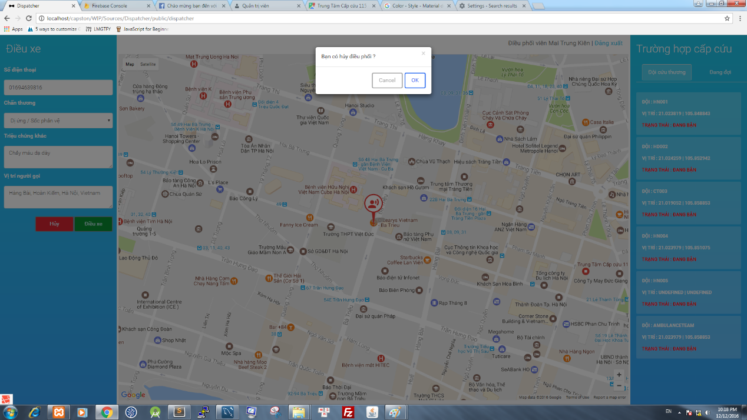

**Figure 2-51: Confirm Cancel dialog**